*­*

|  |  |
| --- | --- |
| *Pacific Gas and Electric Company* | |
| Release 8 Installation Guide | |
|  |  |
|  |  |
| Project | ED AM/GIS |
|  |  |
| Prepared by | Baidya, Subhankar |
| Date | 08/07/2014 |
| Version | 1.0 |
| Version Type | Draft |

|  |  |  |  |
| --- | --- | --- | --- |
| Revision History | | | |
| Document # | Date | Author | Summary of Changes |
| 1.0 | 8/7/14 | Subhankar Baidya | Initial Document Creation |
|  |  |  |  |
|  |  |  |  |
|  |  |  |  |
|  |  |  |  |

# Introduction

## Purpose

This document is intended to detail the implementation and configuration steps required to implement Release 8 Installation Guide. This document describes the various configuration aspects required to complete any manual or automatic patch associated with this release. Each section in this document contains the steps required to patch the system in production.

## Terms Used

|  |  |
| --- | --- |
| OOTB | Out of the box. Unmodified from the commercial version. |
| TFS | Team Foundation Server |

## External Documents

Referenced are any external configuration documents or exports. These are documents that contain more detailed information about configuring a system or documents that can be loaded into an application to perform the configuration detailed in this document.

1. [Folder](\\\\sfetgis-nas01\\sfgispoc_data\\ApplicationDevelopment\\IBM_Delivery\\UFM Data Model 8, stored display\\) containing all necessary files

## List of Fixes

Below is the list of change requests detailing all fixes for the data model for this release:

|  |  |
| --- | --- |
| **CR#** | **Title** |
| 13742 | Add "Ethernet" to the Carrier domain |
| 14584 | PAR #62136 - New Value for ULS Size Domain |
| 14648 | New Value for Conductor Insulation - UG Domain - PAR #60889 |
| 14653 | New Value for Conductor Insulation - UG Domain - PAR #61107 |
| 14806 | Add Value to Conductor Size Domain - PAR #60976 |
| 14848 | Conductor Count Domain Update - PAR #62514 |
| 15016 | Joint Pole Members domain - PAR 63912 |
| 15026 | PAR 24182 Add New Value to Joint Pole Members Domain "VC" |
| 15732 | PAR #61219 - OH DC Add AR to Conductor Material Domain |
| 15861 | SubstationID domain |
| 9331 | PAR 24182: Need to add code/value to 'Joint Pole Members' domain |
| 9156 | PAR 25050: Add Values to Conductor Insulation - UG Domain |
| 9155 | PAR 25485: Add Code/Value to Conductor Material UG Domain |
| 9073 | Add Values To SUB Operating Mechanism |
| 9072 | PAR 23303: Add Values To SUB Transmission Nominal Voltage |
| 9071 | PAR 23348: SUB Transformer Cooling Class |
| 9070 | PAR 23304,24325: Add Values To SUB Interrupting Current Rating |
| 9069 | PAR 23301: Add Values To SUB Rated Amps Domain |
| 8960 | PAR 24146: Need to add a new code/value to "Joint Pole Members" domain |
| 8768 | PAR 20846/21244: Add Values To ULS Material - Duct Bank Domain V8 |
| 8603 | PAR 22401: Add Values To Joint Pole Members Domain V8 |
| 8598 | PAR 22745: Add Code/Value To ConductorCount Domain V8.0 |
| 8586 | ElectricStitchPoint: Change Domain On Field For Subtype |
| 8582 | PAR22391: Add Value To Joint Pole Members Domain V8 (8.3) |
| 14179 | New code/value to the "Capacitor Unit KVAR" domain PAR 58374 |
| 13993 | New Value for Joint Pole Members Domain - PAR #57333 |
| 13864 | Joint Pole Memers Domain Code SJ, WP24 Sacramento PARs 58322 & 58396 |
| 13511 | Stockton WP8 ED PAR 55600 "Conductor Insulation - UG" domain |
| 13495 | RegulatorControlType Domain |
| 13391 | New Value for Joint Pole Members Domain - PAR #53096 |
| 13315 | New Value for Joint Pole Members Domain - PAR #53461 |
| 13314 | Joint Pole Members domain Eureka PAR 53868 WP23 |
| 13153 | Apply the field model name ‘PGE_INSTALLJOBYEAR’ on installationyear field for PrimaryRiser features |
| 13150 | Increase Bar code field size on support structure to 10 |
| 13148 | Add new Domain value 'Trip Saver' to Fuse Link Type Domain |
| 12059 | DA Issue: 'Proposed - Remove' in domain 'Construction Status' |
| 4131 | Need new GIS symbology for 'New' FLISR Mapping Symbol |

## Summary of Steps to Complete Patch

These are the high-level steps to complete the installation and configuration of the data model patch. Use this table as a guide for completing the installation. Links are provided that can lead either within the document for detailed explanations or to external sites such as Sharepoint.

Table of Contents

1. Introduction 3

Purpose 3

Terms Used 3

External Documents 3

List of Fixes 4

Summary of Steps to Complete Patch 5

2. Open a Database Connection in ArcCatalog 8

3. Add "Ethernet" to the Carrier domain 9

4. PAR #62136 - New Value for ULS Size Domain 12

5. New Value for Conductor Insulation - UG Domain - PAR #60889 15

6. New Value for Conductor Insulation - UG Domain - PAR #61107 18

7. Add Value to Conductor Size Domain - PAR #60976 21

8. Conductor Count Domain Update - PAR #62514 24

9. Joint Pole Members domain - PAR 63912 28

10. PAR 64128 Add New Value to Joint Pole Members Domain "VC" 31

11. PAR #61219 - OH DC Add AR to Conductor Material Domain 34

12. SubstationID domain 38

13. PAR 24182: Need to add code/value to 'Joint Pole Members' domain 40

14. PAR 25050: Add Values to Conductor Insulation - UG Domain 43

15. PAR 25485: Add Code/Value to Conductor Material UG Domain 56

16. Add Values to SUB Operating Mechanism 59

17. PAR 23303: Add Values to SUB Transmission Nominal Voltage 62

18. PAR 23348: SUB Transformer Cooling Class 65

19. PAR 23304,24325: Add Values To SUB Interrupting Current Rating 68

20. PAR 23301: Add Values To SUB Rated Amps Domain 72

21. PAR 24146: Need to add a new code/value to "Joint Pole Members" domain 75

22. PAR 20846/21244: Add Values To ULS Material - Duct Bank Domain V8 78

23. PAR 22401: Add Values To Joint Pole Members Domain V8 81

24. PAR 22745: Add Code/Value To ConductorCount Domain V8.0 84

25. ElectricStitchPoint: Change Domain On Field For Subtype 87

26. PAR22391: Add Value To Joint Pole Members Domain V8 (8.3) 89

27. New code/value to the "Capacitor Unit KVAR" domain PAR 58374 92

28. New Value for Joint Pole Members Domain - PAR #57333 95

29. Joint Pole Memers Domain Code SJ, WP24 Sacramento PARs 58322 & 58396 98

30. Stockton WP8 ED PAR 55600 "Conductor Insulation - UG" domain 101

31. RegulatorControlType Domain 104

32. New Value for Joint Pole Members Domain - PAR #53096 108

33. New Value for Joint Pole Members Domain - PAR #53461 111

34. Joint Pole Members domain Eureka PAR 53868 WP23 114

35. Apply the field model name ‘PGE_INSTALLJOBYEAR’ on installationyear field for PrimaryRiser features 117

36. Increase Bar code field size on support structure to 10 121

37. Add new Domain value 'Trip Saver' to Fuse Link Type Domain 131

38. DA Issue: 'Proposed - Remove' in domain 'Construction Status' 134

39. Need new GIS symbology for 'New' FLISR Mapping Symbol 137

Update Data Model Version Table 140

Known Issues 141

# Open a Database Connection in ArcCatalog

1. Open ArcCatalog.
2. Within the Catalog Tree, expand “Database Connections” and open the active connection for this process. This is the connection that is referenced in the change request associated with this document (EDGIS<DB name in the format X#Y> )

# Add "Ethernet" to the Carrier domain

1. Right click on the database connection and at the context menu click on “Properties…”

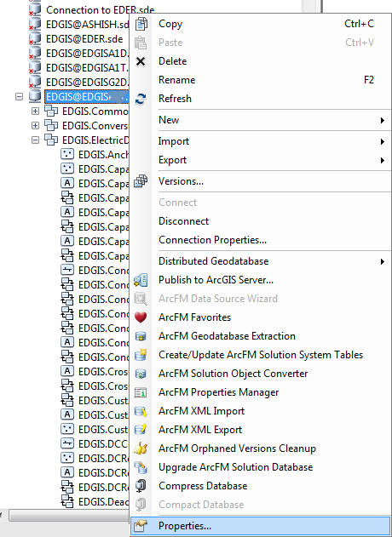

1. At the Database Properties window select Domains tab. Select “Carrier” domain from the list.

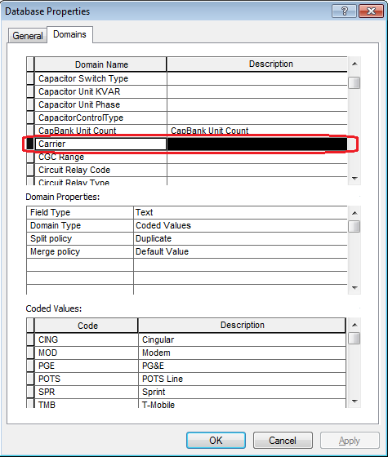

1. Go to the end of the “Coded values” list. Add the highlighted “Code” and “Description” as given in the screenshot. Click OK button.

Code: ETH

Value: Ethernet

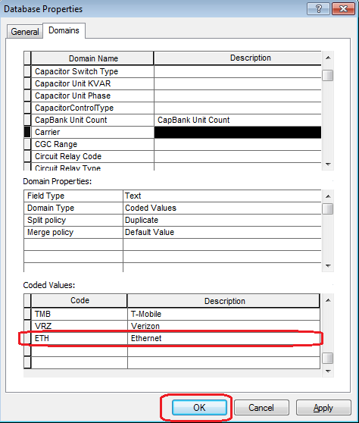

# PAR #62136 - New Value for ULS Size Domain

1. Right click on the database connection and at the context menu click on “Properties…”



1. At the Database Properties window select Domains tab. Select “ULS Size-coded value” domain from the list.

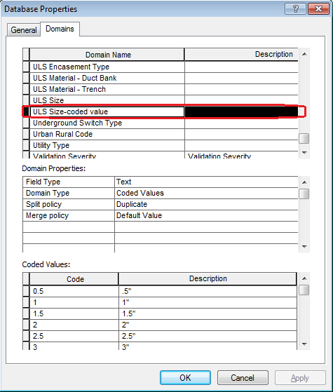

1. Go to the end of the “Coded values” list. Add the highlighted “Code” and “Description” as given in the screenshot. Click OK button.

Code: 2.75

Value: 2.75”

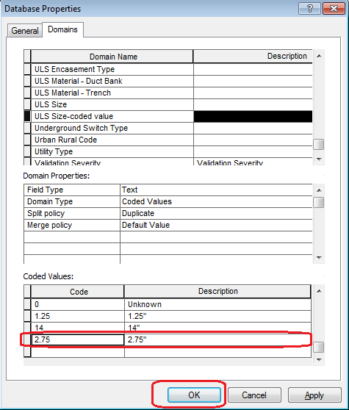

# New Value for Conductor Insulation - UG Domain - PAR #60889

1. Right click on the database connection and at the context menu click on “Properties…”



1. At the Database Properties window select Domains tab. Select “Conductor Insulation - UG” domain from the list.

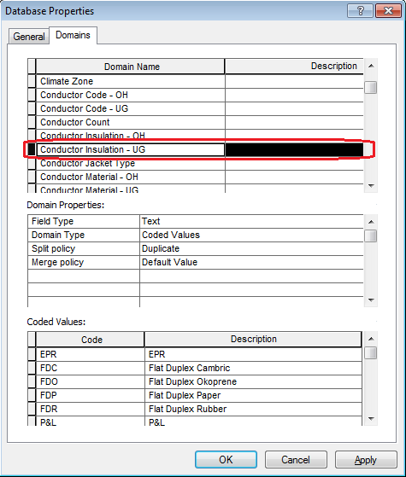

1. Go to the end of the “Coded values” list. Add the highlighted “Code” and “Description” as given in the screenshot. Click OK button.

Code: THHN

Value: Thermoplastic High Heat Nylon

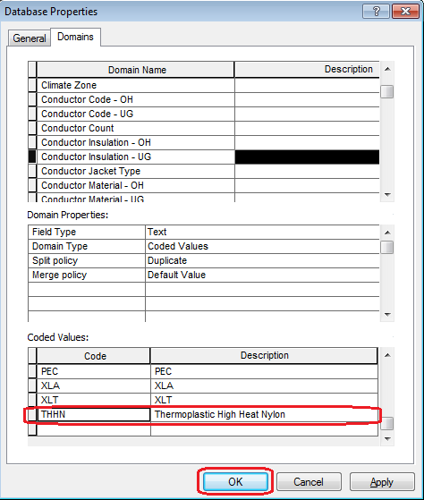

# New Value for Conductor Insulation - UG Domain - PAR #61107

1. Right click on the database connection and at the context menu click on “Properties…”



1. At the Database Properties window select Domains tab. Select “Conductor Insulation - UG” domain from the list.



1. Go to the end of the “Coded values” list. Add the highlighted “Code” and “Description” as given in the screenshot. Click OK button.

Code: THWN

Value: THWN

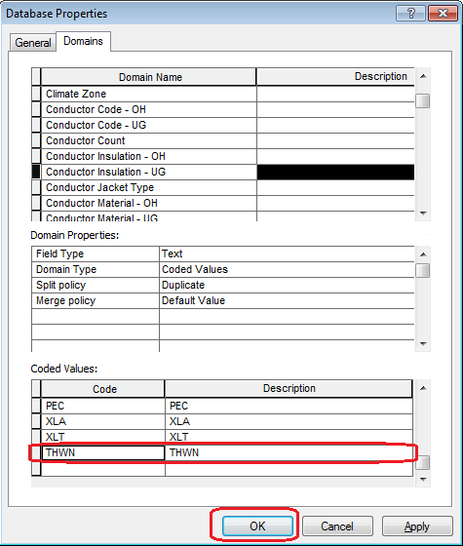

# Add Value to Conductor Size Domain - PAR #60976

1. Right click on the database connection and at the context menu click on “Properties…”



1. At the Database Properties window select Domains tab. Select “Conductor Size” domain from the list.

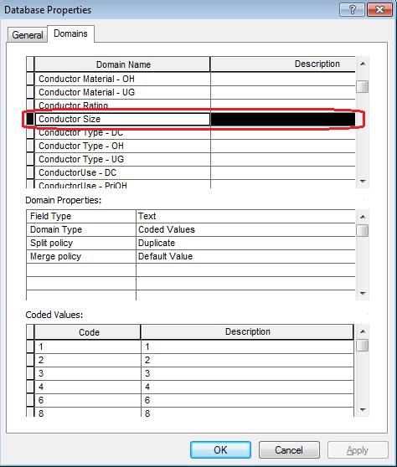

1. Go to the end of the “Coded values” list. Add the highlighted “Code” and “Description” as given in the screenshot. Click OK button.

Code: 14

Value: 14

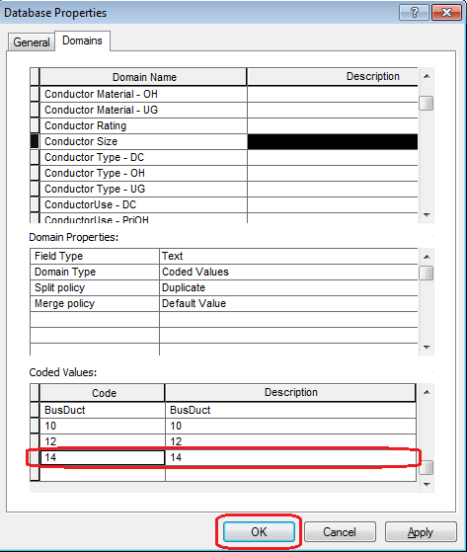

# Conductor Count Domain Update - PAR #62514

1. Right click on the database connection and at the context menu click on “Properties…”



1. At the Database Properties window select Domains tab. Select “Conductor Count” domain from the list.

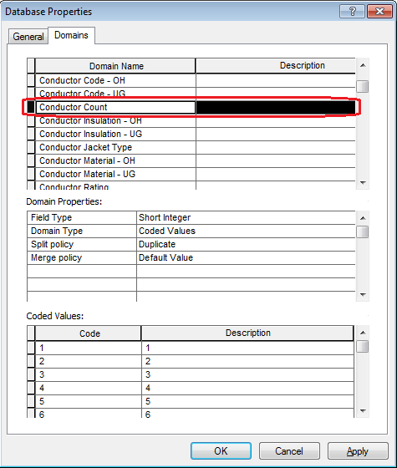

1. Go to the end of the “Coded values” list. Add the highlighted “Codes” and “Descriptions” as given in the screenshot. Click OK button.

**Code** **Value**

16 16

17 17

18 18

19 19

20 20

21 21

22 22

23 23

24 24

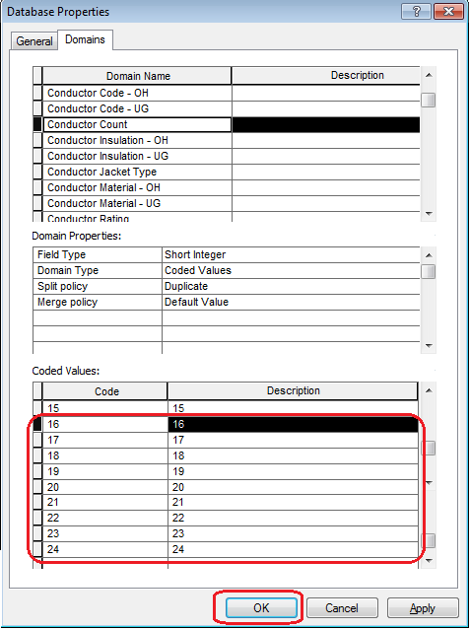

# Joint Pole Members domain - PAR 63912

1. Right click on the database connection and at the context menu click on “Properties…”



1. At the Database Properties window select Domains tab. Select “Joint Pole Members” domain from the list.

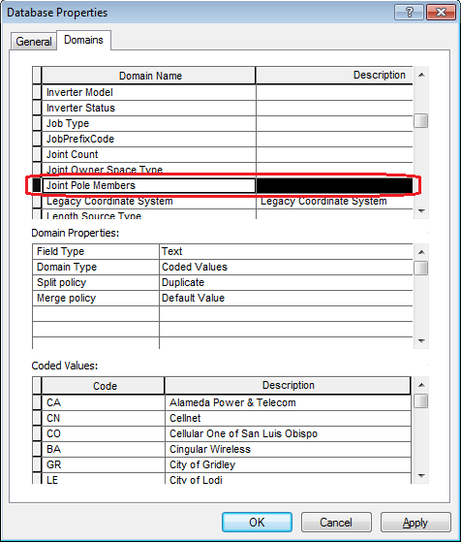

1. Go to the end of the “Coded values” list. Add the highlighted “Code” and “Description” as given in the screenshot. Click OK button.

Code: LT

Value: LT

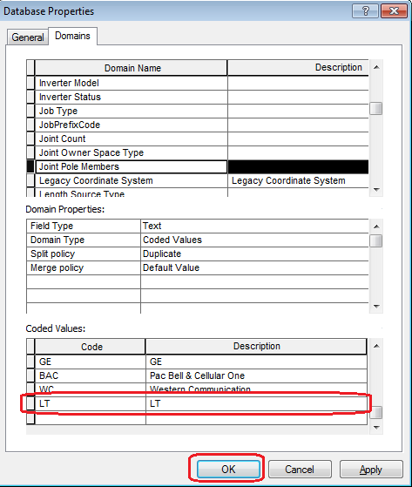

# PAR 64128 Add New Value to Joint Pole Members Domain "VC"

1. Right click on the database connection and at the context menu click on “Properties…”



1. At the Database Properties window select Domains tab. Select “Joint Pole Members” domain from the list.



1. Go to the end of the “Coded values” list. Add the highlighted “Code” and “Description” as given in the screenshot. Click OK button.

Code: VC

Value: VC

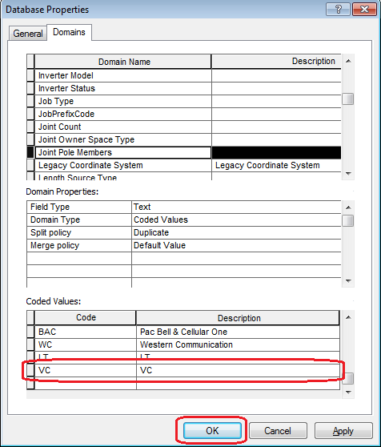

# PAR #61219 - OH DC Add AR to Conductor Material Domain

1. Right click on the database connection and at the context menu click on “Properties…”



1. At the Database Properties window select Domains tab. Go to the end of the Domain Name List. Add the new “Domain Name” -- **Conductor Material - DC** -- and the highlighted “Domain Properties”. Then click “**Apply**” button.

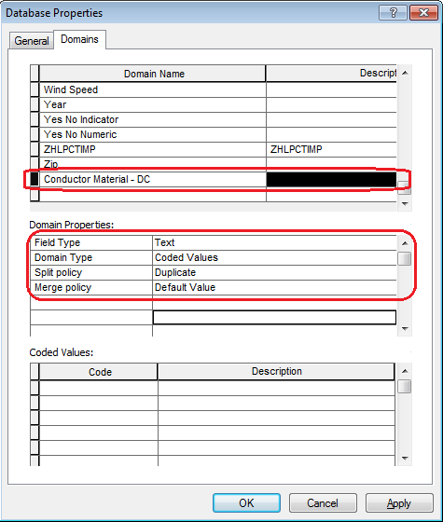

1. Go to the “Coded values” list. Add the following “Codes” and “Descriptions” (see the screenshot). Click OK button.

**Code Value**

AAC AAC

A AL

C CU

CUWD Copper Weld

HDCU Hard Drawn Copper

SDCU Soft Drawn Copper

STCU Stranded Copper

STL Steel

NONE None

UNK Unknown

BusDuct BusDuct

CL Copper covered Lead

L Lead

PL Paper covered Lead

AR ACSR

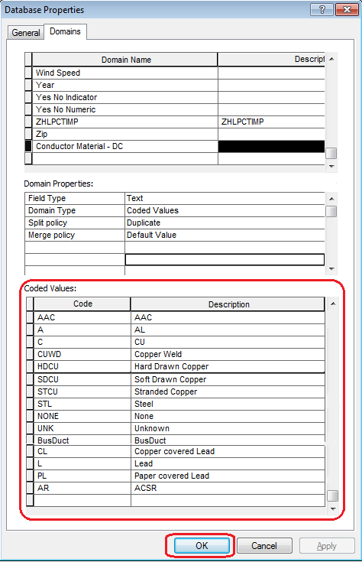

# SubstationID domain

1. Right click on the EDGIS.PGE_CIRCUITCOLOR table at the root. At the context menu, click on “Properties…”

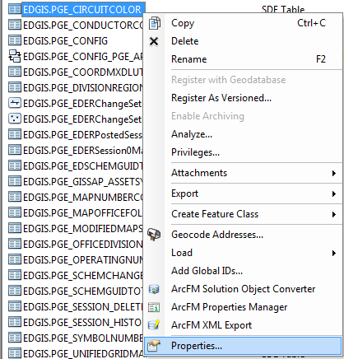

1. Go to “Fields” Tab. Add CIRCUITNAME field as below:

Name: CIRCUITNAME

Alias: Circuit Name

DataType: Text

Length: 50

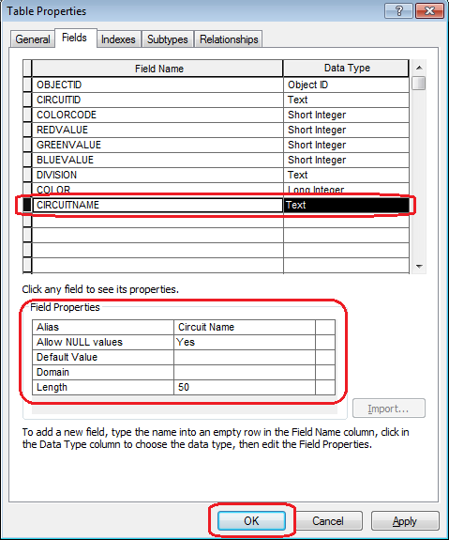

1. Click on Apply. Then click OK button.

# PAR 24182: Need to add code/value to 'Joint Pole Members' domain

1. Right click on the database connection and at the context menu click on “Properties…”



1. At the Database Properties window select Domains tab. Select “Joint Pole Members” domain from the list.



1. Go to the end of the “Coded values” list. Add the highlighted “Code” and “Description” as given in the screenshot. Click OK button.

Code: GC

Value: GC

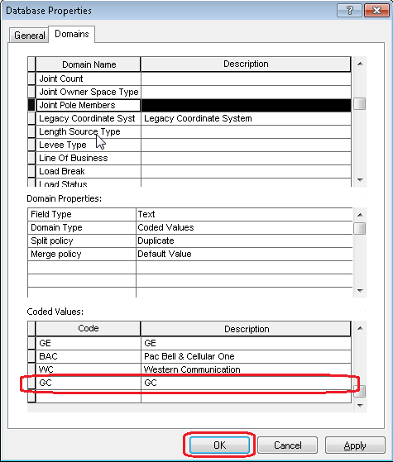

# PAR 25050: Add Values to Conductor Insulation - UG Domain

1. Right click on the database connection and at the context menu click on “Properties…”



1. At the Database Properties window select Domains tab. Select “Conductor Insulation – UG” domain from the list.

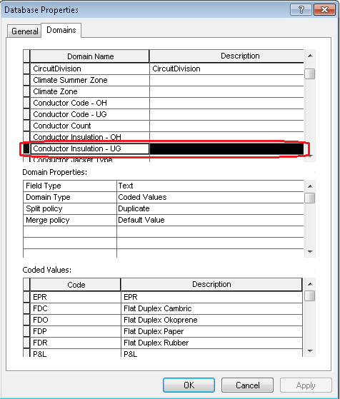

1. Go to the end of the “Coded values” list. Add the highlighted “Codes” and “Descriptions” as given in the screenshot. Click OK button.

**Code** **Value**

LEAD RUBBER LEAD RUBBER

FLAMENOL FLAMENOL

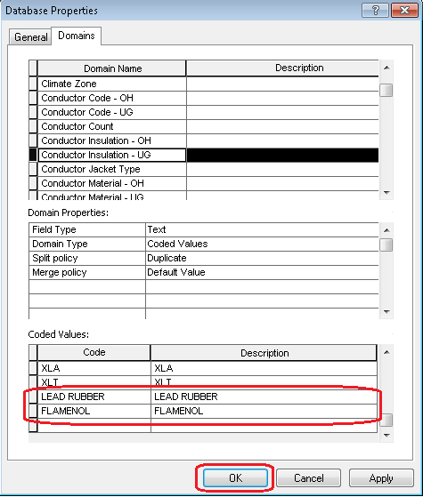

1. Right click on EDGIS.SecUGConductorInfo table and at the context menu click on “Properties…”

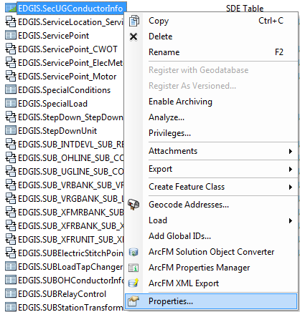

1. Select “Fields” tab. Add a new field as shown below:

Field Name: INSULATION_TEMP

Data Type: Text

Alias: Insulation

Allow Null values: Yes

Domain: Conductor Insulation - UG

Length: 15

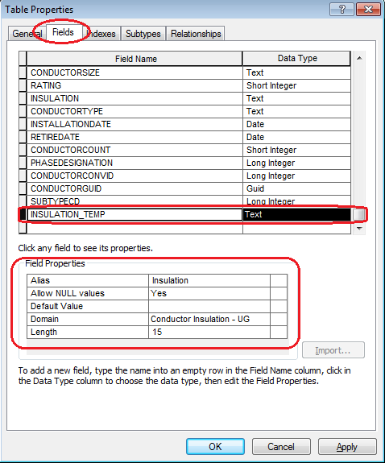

Click Apply. Click OK.

1. Open SQL Plus.
2. Log in using the same server as was used in section 2 as “**SDE**” user – i.e. user name is SDE.

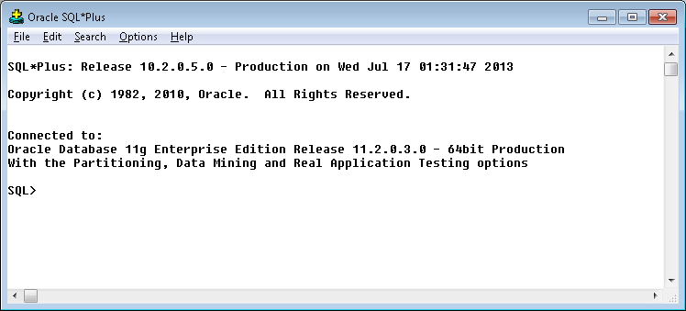

1. Run the SQL script as given below:

set serveroutput on

declare

var_sqlString varchar2(250);

begin

update EDGIS.SecUGConductorInfo set insulation_temp = insulation;

dbms_output.put_line('SecUGConductorInfo updated');

select 'update ' || (select 'edgis.' || (select 'A'||registration_id from table_registry where table_name='SECUGCONDUCTORINFO')from dual)

|| ' set insulation_temp = insulation' into var_sqlString from dual;

dbms_output.put_line(var_sqlString);

execute immediate var_sqlString;

dbms_output.put_line('delta table [A] updated');

commit;

end;

/

1. Exit from SQL PLUS.
2. Right click on EDGIS.SecUGConductorInfo table and at the context menu click on “Properties…”



1. Select “Fields” tab. Select INSULATION Field. Delete the field by pressing “Delete” key on the keyboard. Click Apply. Click OK.

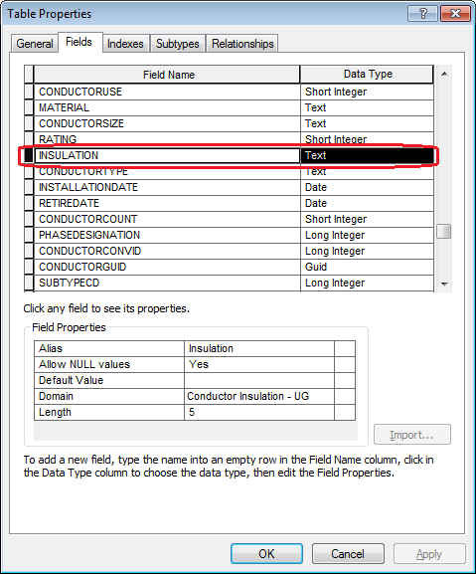

1. Right click on EDGIS.SecUGConductorInfo table and at the context menu click on “Properties…” again.



1. Select “Fields” tab. Add a new field as shown below:

Field Name: INSULATION

Data Type: Text

Alias: Insulation

Allow Null values: Yes

Domain: Conductor Insulation - UG

Length: 15

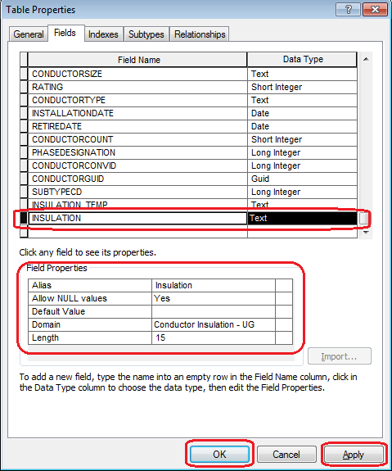

Click Apply. Click OK.

1. Open SQL Plus.
2. Log in using the same server as was used in section 2 as “**SDE**” user – i.e. user name is SDE.



1. Run the SQL statement as given below:

set serveroutput on

declare

var_sqlString varchar2(250);

begin

update EDGIS.SecUGConductorInfo set insulation = insulation_temp;

dbms_output.put_line(' EDGIS.SecUGConductorInfo updated');

select 'update ' || (select 'edgis.' || (select 'A'||registration_id from table_registry where table_name='SECUGCONDUCTORINFO')from dual)

|| ' set insulation = insulation_temp' into var_sqlString from dual;

dbms_output.put_line(var_sqlString);

execute immediate var_sqlString;

dbms_output.put_line('delta table [A] updated');

commit;

end;

/

1. Exit from SQL PLUS.
2. Right click on EDGIS.SecUGConductorInfo table and at the context menu click on “Properties…”



1. Select “Fields” tab. Select INSULATION_TEMP Field. Delete the field by pressing “Delete” key on the keyboard. Click Apply. Click OK.

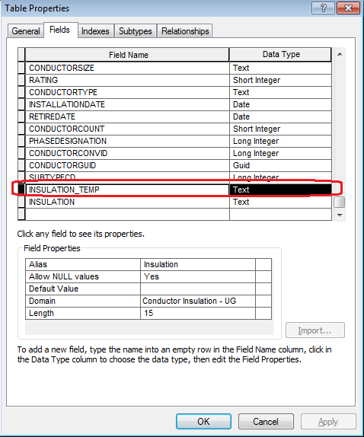

# PAR 25485: Add Code/Value to Conductor Material UG Domain

1. Right click on the database connection and at the context menu click on “Properties…”



1. At the Database Properties window select Domains tab. Select “Conductor Material - UG” domain from the list.

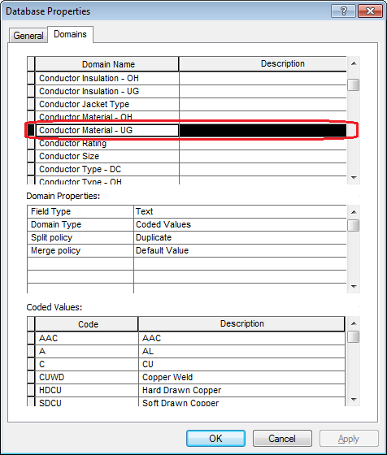

1. Go to the end of the “Coded values” list. Add the highlighted “Code” and “Description” as given in the screenshot. Click OK button.

Code = AR Value = ACSR

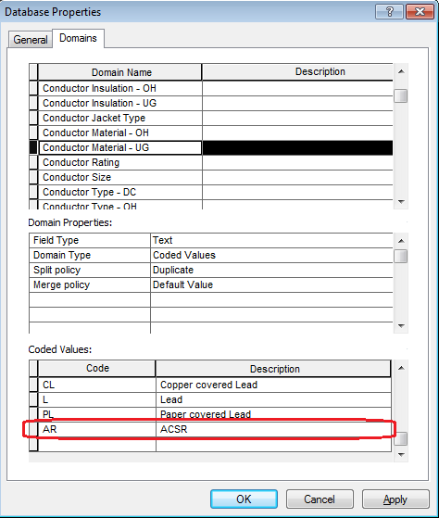

# Add Values to SUB Operating Mechanism

1. Right click on the database connection and at the context menu click on “Properties…”



1. At the Database Properties window select Domains tab. Select “SUB Operating Mechanism” domain from the list.

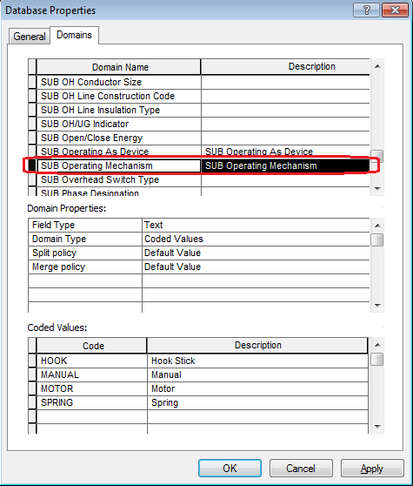

1. Go to the end of the “Coded values” list. Add the highlighted “Code” and “Description” as given in the screenshot. Click OK button.

Code = HYDRAULIC

Value = Hydraulic

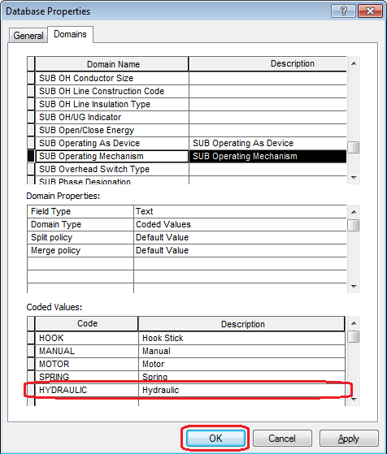

# PAR 23303: Add Values to SUB Transmission Nominal Voltage

1. Right click on the database connection and at the context menu click on “Properties…”



1. At the Database Properties window select Domains tab. Select “SUB Transmission Nominal Voltage” domain from the list.

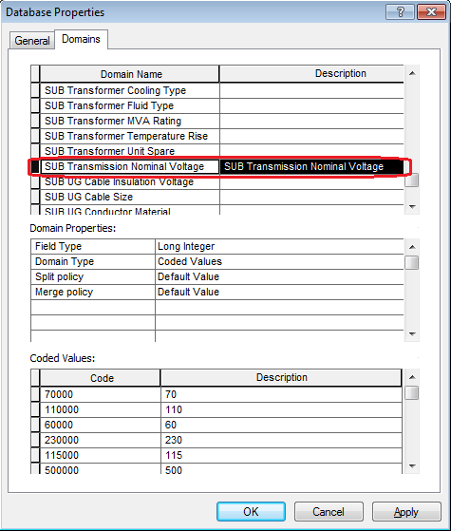

1. Go to the end of the “Coded values” list. Add the highlighted “Code” and “Description” as given in the screenshot. Click OK button.

Code = 18000

Value = 18

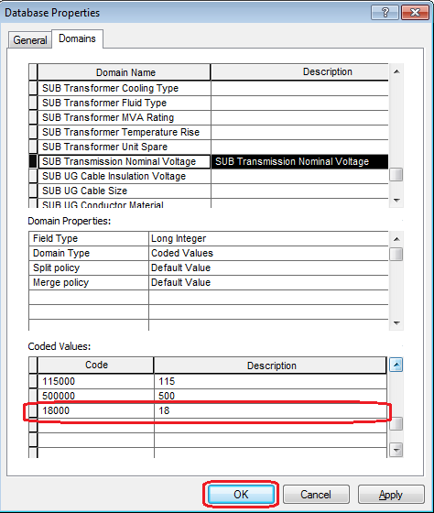

# PAR 23348: SUB Transformer Cooling Class

1. Right click on the database connection and at the context menu click on “Properties…”



1. At the Database Properties window select Domains tab. Select “SUB Transformer Cooling Class” domain from the list.

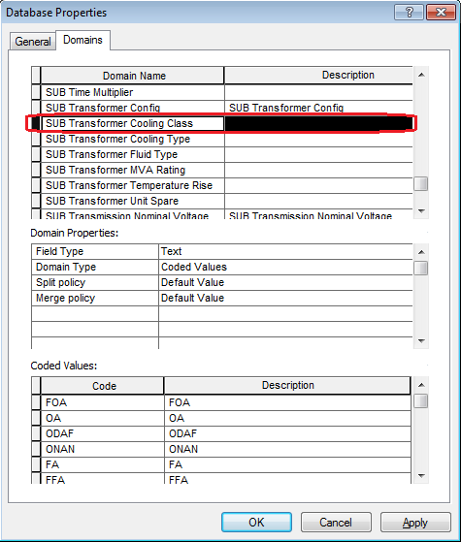

1. Go to the end of the “Coded values” list. Add the highlighted “Codes” and “Descriptions” as given in the screenshot. Click OK button.

**Code Description**

ONFA ONFA

FA/FA FA/FA

ONANF1 ONANF1

ONANF2 ONANF2

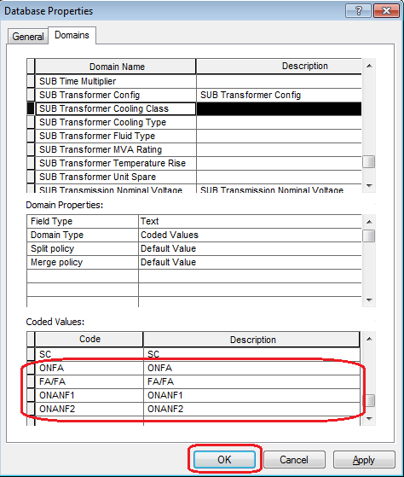

# PAR 23304,24325: Add Values To SUB Interrupting Current Rating

1. Right click on the database connection and at the context menu click on “Properties…”



1. At the Database Properties window select Domains tab. Select “SUB Interrupting Current Rating” domain from the list.

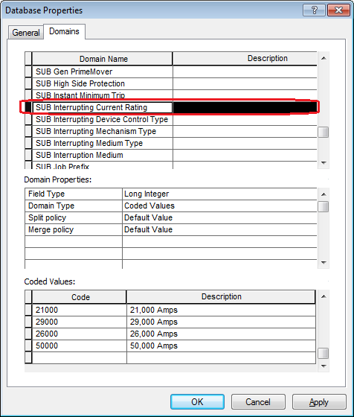

1. Go to the end of the “Coded values” list. Add the highlighted “Codes” and “Descriptions” as given in the screenshot. Click OK button.

**Code Description**

200 200 Amps

15500 15,500 Amps

61000 61,000 Amps

63000 63,000 Amps

38000 38,000 Amps

1600 1,600 Amps

28000 28,000 Amps

7000 7,000 Amps

50000 50,000 Amps [Add this only if it is not already added in the domain]

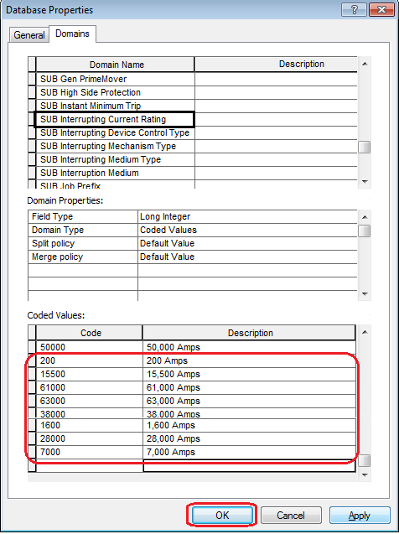

# PAR 23301: Add Values To SUB Rated Amps Domain

1. Right click on the database connection and at the context menu click on “Properties…”



1. At the Database Properties window select Domains tab. Select “SUB Rated Amps” domain from the list.

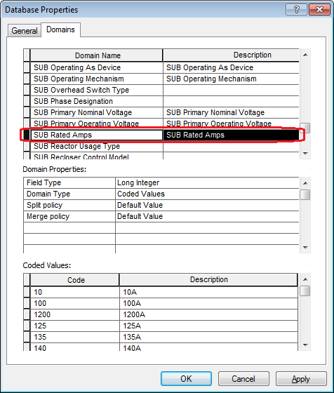

1. Go to the end of the “Coded values” list. Add the highlighted “Code” and “Description” as given in the screenshot. Click OK button.

Code = 1500

Value = 1500A

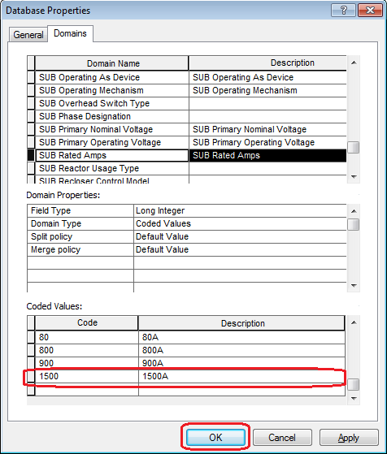

# PAR 24146: Need to add a new code/value to "Joint Pole Members" domain

1. Right click on the database connection and at the context menu click on “Properties…”



1. At the Database Properties window select Domains tab. Select “Joint Pole Members” domain from the list.



1. Go to the end of the “Coded values” list. Add the highlighted “Code” and “Description” as given in the screenshot. Click OK button.

Code = WTC

Value = Western California Telephone Co

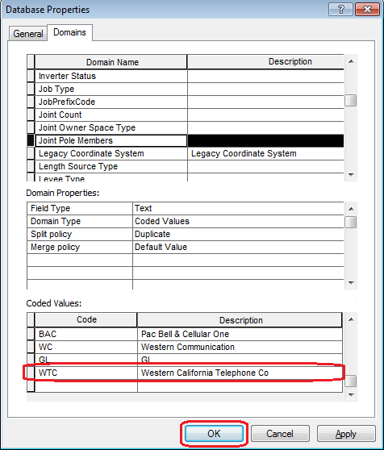

# PAR 20846/21244: Add Values To ULS Material - Duct Bank Domain V8

1. Right click on the database connection and at the context menu click on “Properties…”



1. At the Database Properties window select Domains tab. Select “ULS Material - Duct Bank” domain from the list.

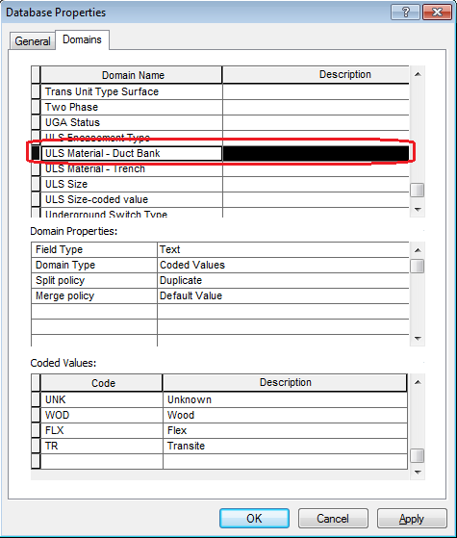

1. Go to the end of the “Coded values” list. Add the highlighted “Codes” and “Descriptions” as given in the screenshot. Click OK button.

Code = SS; Value = Soapstone

Code = BI; Value = Bituminous

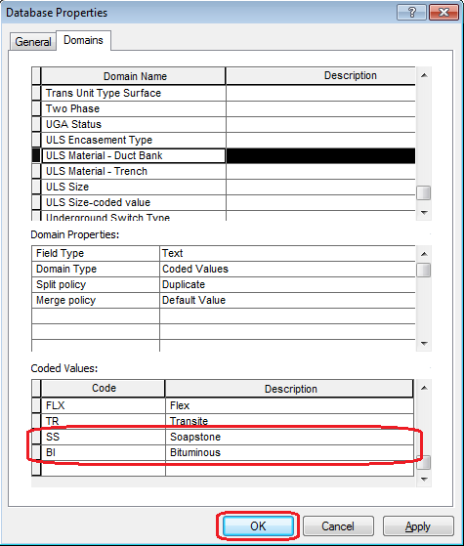

# PAR 22401: Add Values To Joint Pole Members Domain V8

1. Right click on the database connection and at the context menu click on “Properties…”



1. At the Database Properties window select Domains tab. Select “Joint Pole Members” domain from the list.



1. Go to the end of the “Coded values” list. Add the highlighted “Code” and “Description” as given in the screenshot. Click OK button.

Code: GL

Value: GL

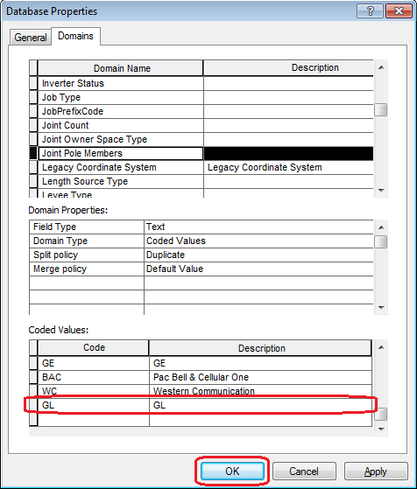

# PAR 22745: Add Code/Value To ConductorCount Domain V8.0

1. Right click on the database connection and at the context menu click on “Properties…”



1. At the Database Properties window select Domains tab. Select “Conductor Count” domain from the list.

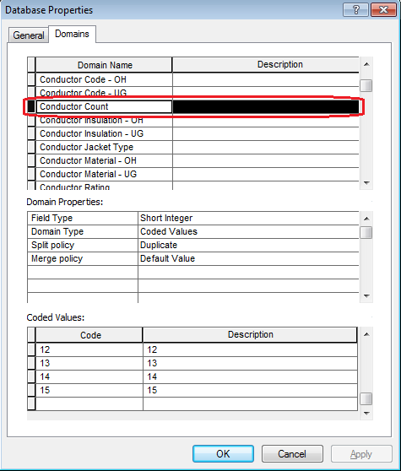

1. Go to the end of the “Coded values” list. Add the highlighted “Code” and “Description” as given in the screenshot. Click OK button.

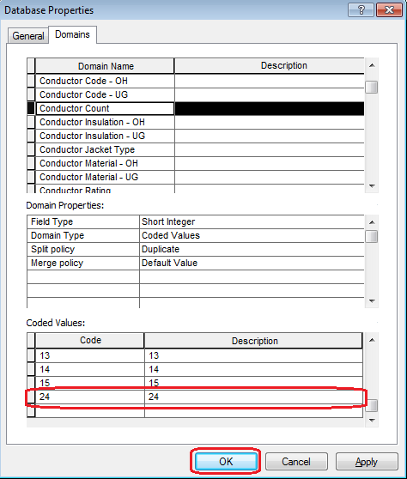

# ElectricStitchPoint: Change Domain On Field For Subtype

1. Under EDGIS.ElectricDataset, right click on EDGIS.ElectricStitchPoint feature class and at the context menu click on “Properties…”

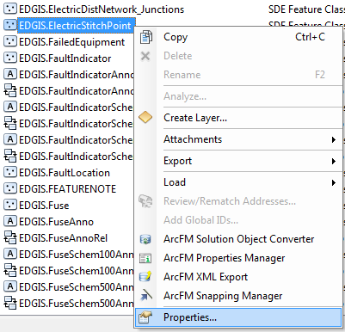

1. Select “Subtypes” tab. Select “Load” subtype at “Subtypes” list.

At “Default Values and Domains” list, change the domain name of NOMINALVOLTAGE field as given below:

Subtype: Load

Field: NominalVoltage

Old Domain: StitchPointNominalVoltage

New Domain: Not Applicable - Integer

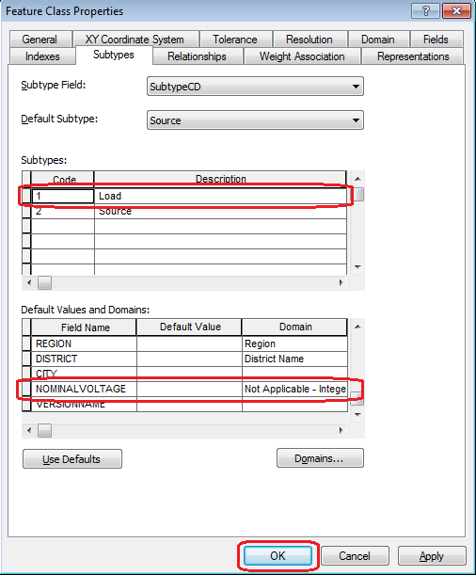

Click OK.

# PAR22391: Add Value To Joint Pole Members Domain V8 (8.3)

1. Right click on the database connection and at the context menu click on “Properties…”



1. At the Database Properties window select Domains tab. Select “Joint Pole Members” domain from the list.



1. Go to the end of the “Coded values” list. Add the highlighted “Code” and “Description” as given in the screenshot. Click OK button.

Code = WC

Value = Western Communication

[Add this only if it is not already added in the domain]

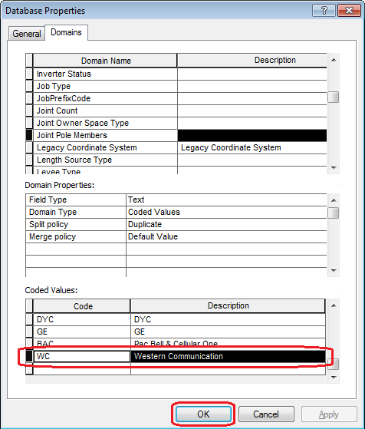

# New code/value to the "Capacitor Unit KVAR" domain PAR 58374

1. Right click on the database connection and at the context menu click on “Properties…”



1. At the Database Properties window select Domains tab. Select “Capacitor Unit KVAR” domain from the list.

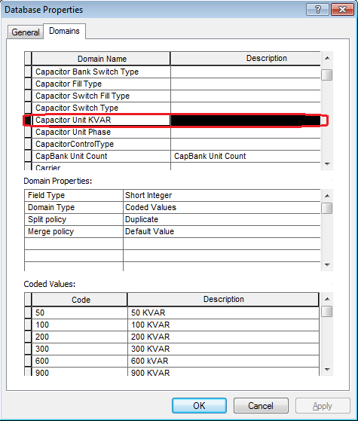

1. Go to the end of the “Coded values” list. Add the highlighted “Code” and “Description” as given in the screenshot. Click OK button.

Code = 250

Value = 250 KVAR

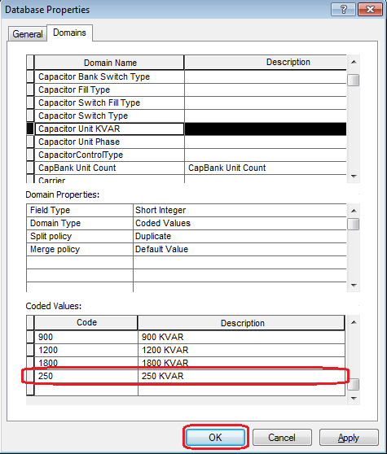

# New Value for Joint Pole Members Domain - PAR #57333

1. Right click on the database connection and at the context menu click on “Properties…”



1. At the Database Properties window select Domains tab. Select “Joint Pole Members” domain from the list.



1. Go to the end of the “Coded values” list. Add the highlighted “Code” and “Description” as given in the screenshot. Click OK button.

Code: GW

Value: Great Western Power

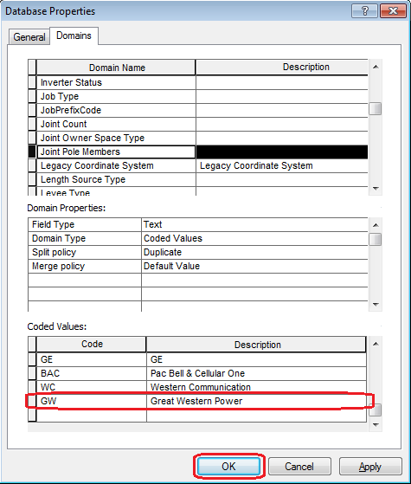

# Joint Pole Memers Domain Code SJ, WP24 Sacramento PARs 58322 & 58396

1. Right click on the database connection and at the context menu click on “Properties…”



1. At the Database Properties window select Domains tab. Select “Joint Pole Members” domain from the list.



1. Go to the end of the “Coded values” list. Add the highlighted “Code” and “Description” as given in the screenshot. Click OK button.

Code = SJ; Value = SJ

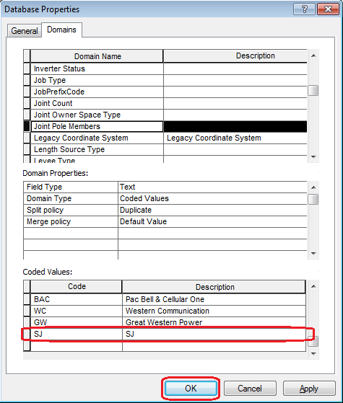

# Stockton WP8 ED PAR 55600 "Conductor Insulation - UG" domain

1. Right click on the database connection and at the context menu click on “Properties…”



1. At the Database Properties window select Domains tab. Select “Conductor Insulation - UG” domain from the list.

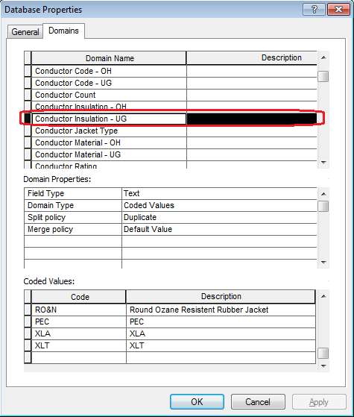

1. Go to the end of the “Coded values” list. Add the highlighted “Code” and “Description” as given in the screenshot. Click OK button.

Code = TW; Value = Thermoplastic Weatherproof

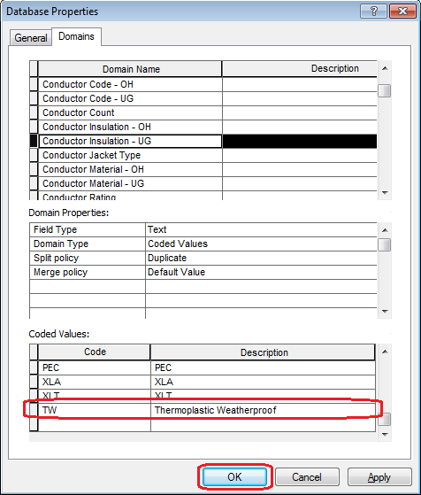

# RegulatorControlType Domain

1. Right click on the database connection and at the context menu click on “Properties…”



1. At the Database Properties window select Domains tab. Select “RegulatorControlType” domain from the list.

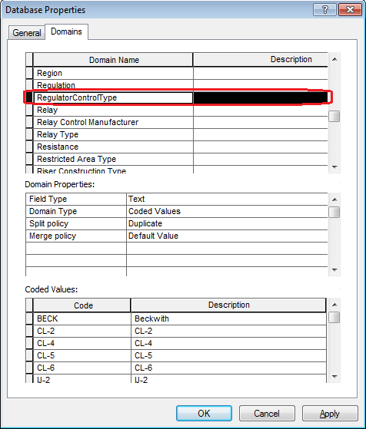

1. Go to the end of the “Coded values” list. Add the highlighted “Codes” and “Descriptions” as given in the screenshot. Click OK button.

Code Value

UVR1 UVR1

CL5A CL5A

CL5B CL5B

CL5C CL5C

CL5D CL5D

CL5E CL5E

CL6A CL6A

CL6B CL6B

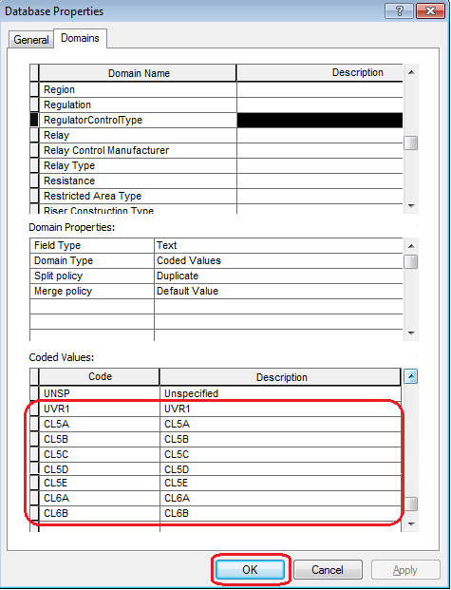

# New Value for Joint Pole Members Domain - PAR #53096

1. Right click on the database connection and at the context menu click on “Properties…”



1. At the Database Properties window select Domains tab. Select “Joint Pole Members” domain from the list.

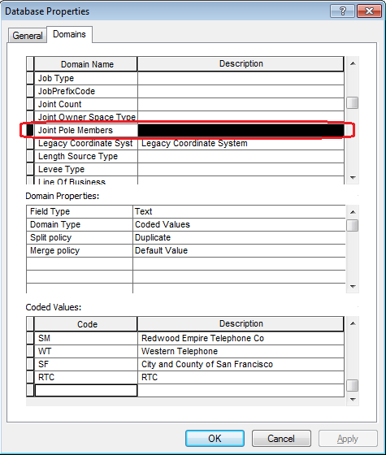

1. Go to the end of the “Coded values” list. Add the highlighted “Code” and “Description” as given in the screenshot. Click OK button.

Code: PTPG

Value: PTPG

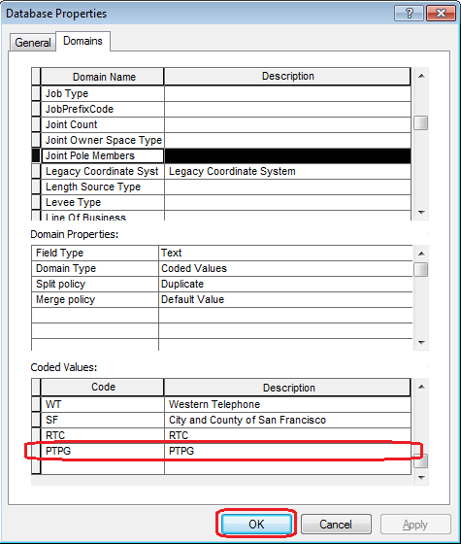

# New Value for Joint Pole Members Domain - PAR #53461

1. Right click on the database connection and at the context menu click on “Properties…”



1. At the Database Properties window select Domains tab. Select “Joint Pole Members” domain from the list.



1. Go to the end of the “Coded values” list. Add the highlighted “Code” and “Description” as given in the screenshot. Click OK button.

Code: HBTV

Value: HBTV

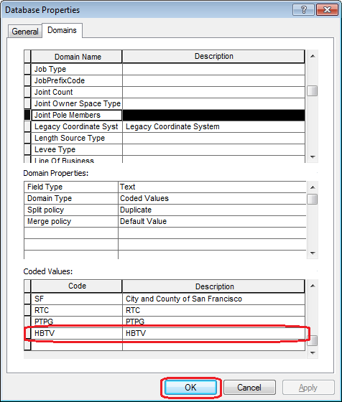

# Joint Pole Members domain Eureka PAR 53868 WP23

1. Right click on the database connection and at the context menu click on “Properties…”



1. At the Database Properties window select Domains tab. Select “Joint Pole Members” domain from the list.



1. Go to the end of the “Coded values” list. Add the highlighted “Code” and “Description” as given in the screenshot. Click OK button.

Code = WO

Value = WO

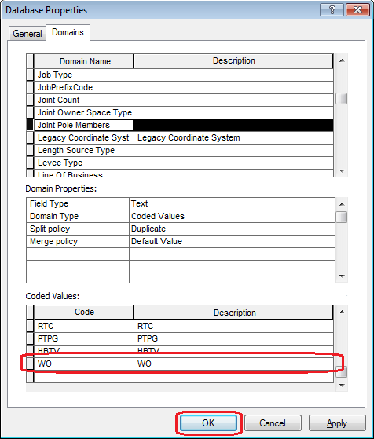

# Apply the field model name ‘PGE_INSTALLJOBYEAR’ on installationyear field for PrimaryRiser features

1. Under EDGIS.ElectricDataset, right click on EDGIS.PrimaryRiser feature class and at the context menu click on “ArcFM Properties Manager”

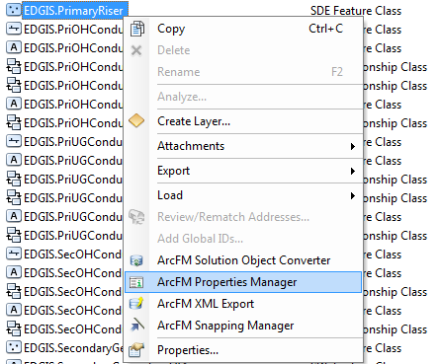

1. Go to “Field Model Names” tab. Select INSTALLJOBYEAR field from the List.

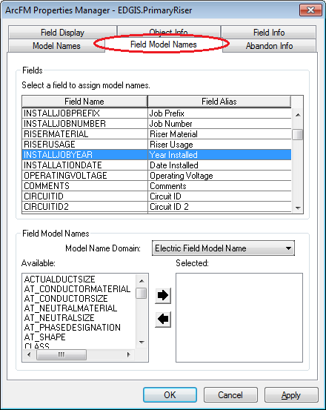

1. Select “PGE ED Field Model Name” from the dropdown. Select “PGE_INSTALLJOBYEAR” model name from the “Available” list and double click on it.

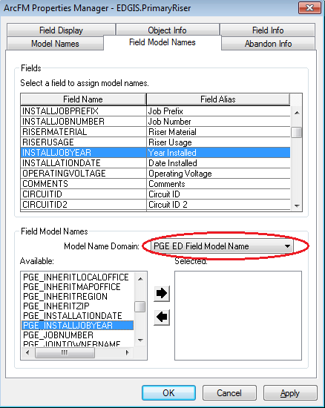

1. “PGE_INSTALLJOBYEAR” model name will be displayed in “Selected” List.

Click Apply. Click OK.

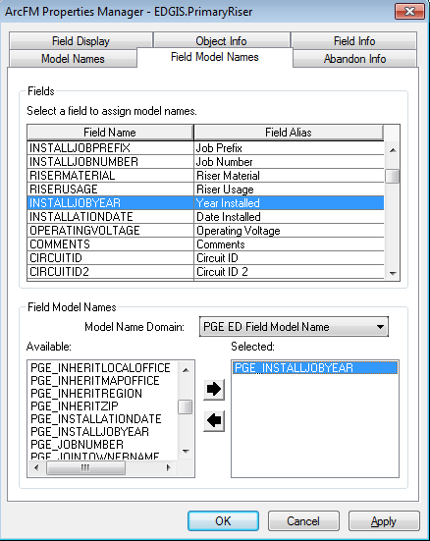

# Increase Bar code field size on support structure to 10

1. Under EDGIS.ElectricDataset, right click on EDGIS.SupportStructure feature class and at the context menu click on “Properties…”

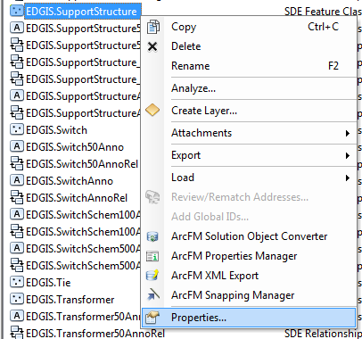

1. Select “Fields” tab. Add a new field as shown below:

Field Name: BARCODE_TEMP

Data Type: Long Integer

Alias: Bar Code

Allow Null values: Yes

Precision: 10

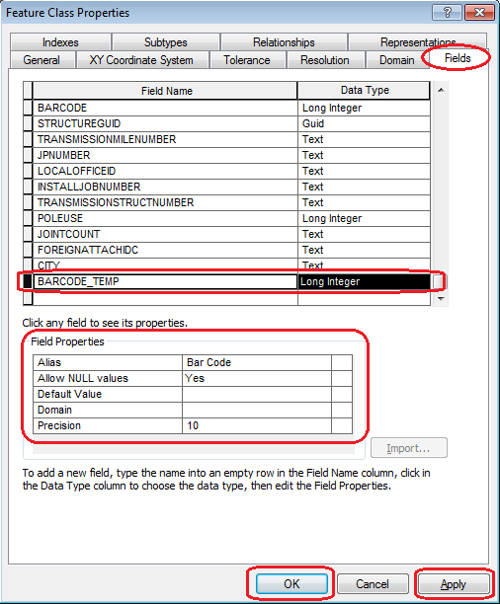

Click Apply. Click OK.

1. Open SQL Plus.
2. Log in using the same server as was used in section 2 as “**SDE**” user – i.e. user name is SDE.



1. Run the SQL statement as given below:

set serveroutput on

declare

var_sqlString varchar2(250);

begin

update edgis.supportstructure set barcode_temp = barcode;

dbms_output.put_line('supportstructure updated');

select 'update ' || (select 'edgis.' || (select 'A'||registration_id from table_registry where table_name='SUPPORTSTRUCTURE')from dual)

|| ' set barcode_temp = barcode' into var_sqlString from dual;

dbms_output.put_line(var_sqlString);

execute immediate var_sqlString;

dbms_output.put_line('delta table [A] updated');

commit;

end;

/

1. Exit from SQL PLUS.
2. Under EDGIS.ElectricDataset, right click on EDGIS.SupportStructure feature class and at the context menu click on “Properties…” again.



1. Select “Fields” tab. Select BARCODE Field. Delete the field by pressing “Delete” key on the keyboard. Click Apply. Click OK.

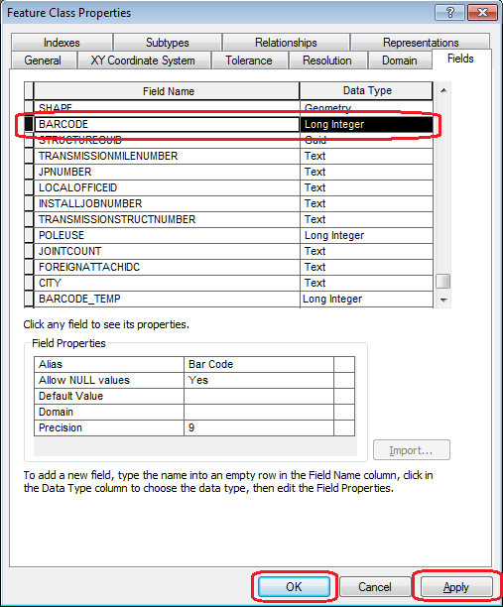

1. Right click on EDGIS.SupportStructure feature class and at the context menu click on “Properties…” again.



1. Select “Fields” tab. Add a new field as shown below:

Field Name: BARCODE

Data Type: Long Integer

Alias: Bar Code

Allow Null values: Yes

Precision: 10

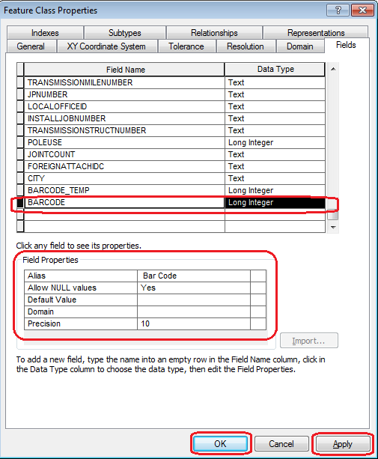

Click Apply. Click OK.

1. Open SQL Plus.
2. Log in using the same server as was used in section 2 as “**SDE**” user – i.e. user name is SDE.



1. Run the SQL statement as given below:

set serveroutput on

declare

var_sqlString varchar2(250);

begin

update edgis.supportstructure set barcode = barcode_temp;

dbms_output.put_line('edgis.supportstructure updated');

select 'update ' || (select 'edgis.' || (select 'A'||registration_id from table_registry where table_name='SUPPORTSTRUCTURE')from dual)

|| ' set barcode = barcode_temp' into var_sqlString from dual;

dbms_output.put_line(var_sqlString);

execute immediate var_sqlString;

dbms_output.put_line('delta table [A] updated');

commit;

end;

/

1. Exit from SQL PLUS.
2. Right click on EDGIS.SupportStructure feature class and at the context menu click on “Properties…”



1. Select “Fields” tab. Select BARCODE_TEMP Field. Delete the field by pressing “Delete” key on the keyboard. Click Apply. Click OK.

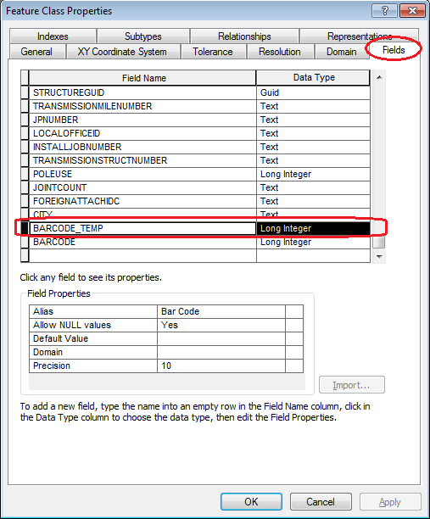

# Add new Domain value 'Trip Saver' to Fuse Link Type Domain

1. Right click on the database connection and at the context menu click on “Properties…”



1. At the Database Properties window select Domains tab. Select “Fuse Link Type” domain from the list.

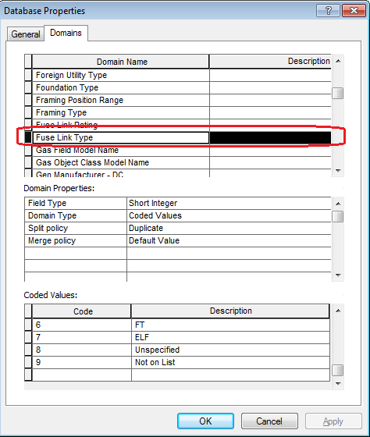

1. Go to the end of the “Coded values” list. Add the highlighted “Code” and “Description” as given in the screenshot. Click OK button.

Code: 10

Value: Trip Saver

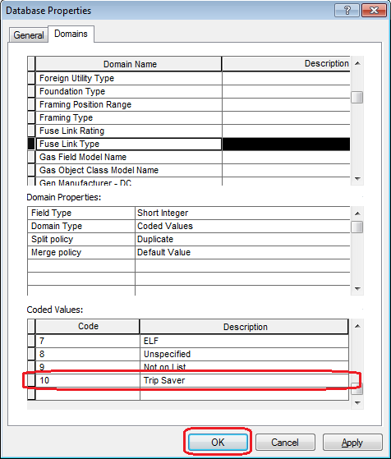

# DA Issue: 'Proposed - Remove' in domain 'Construction Status'

1. Right click on the database connection and at the context menu click on “Properties…”



1. At the Database Properties window select Domains tab. Select “Construction Status” domain from the list.

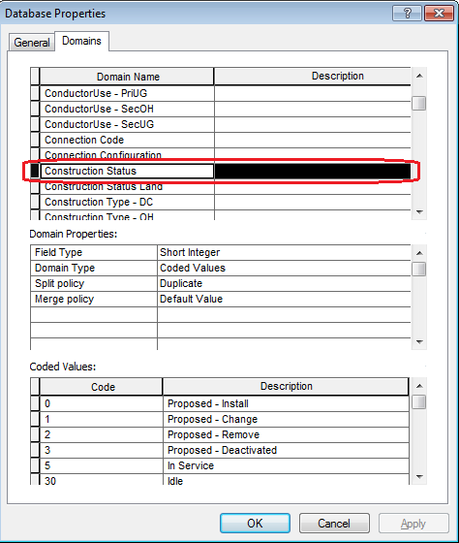

1. Go to the end of the “Coded values” list. Select the highlighted “Codes” as given in the screenshot. Press “Delete” key on the keyboard. Click Apply. Click OK button.

**Code** **Value**

1 Proposed - Change

2 Proposed - Remove

3 Proposed – Deactivated

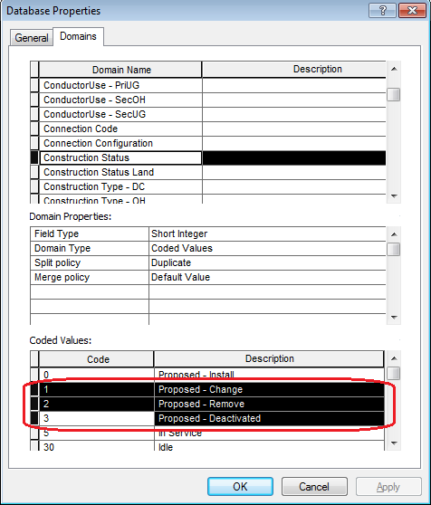

# Need new GIS symbology for 'New' FLISR Mapping Symbol

1. Right click on the database connection and at the context menu click on “Properties…”



1. At the Database Properties window select Domains tab. Select “Underground Switch Type” domain from the list.

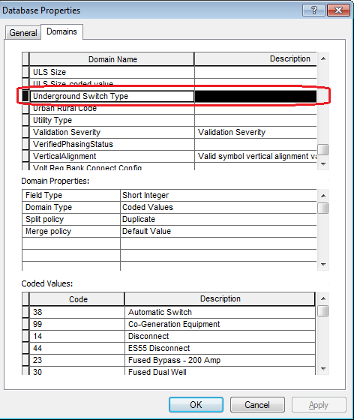

1. Go to the end of the “Coded values” list. Add the highlighted “Code” and “Description” as given in the screenshot. Click OK button.

Code: 18

Value: SCADA Switch

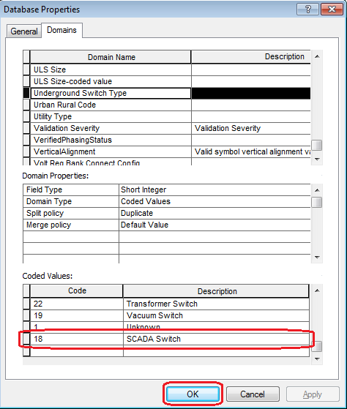

# Update Data Model Version Table

**Database Configuration:**

1. Open SQL Plus.
2. Log in using the same server and user as was used in section 2.  
     
   
3. Run the SQL below:

update edgis.pgedatamodelversion set currentidc='N' where currentidc='Y';

insert into edgis.pgedatamodelversion (OBJECTID, CURRENTIDC, DATEAPPLIED, APPLIEDBYPERSONNAME, MODELVERSION) values (**<*max(objectid) + 1*>**,'Y',sysdate,'**<*INSERT TEAM MEMBER DONE BY*>**','**8.6** GOLD');

commit;

# Known Issues

<Please List any other issues encountered here while following the document>